**Git Assignment Day-2**

Git Hub

goto https://github.com/

Cretae account and Signin to the <https://github.com/>

create repository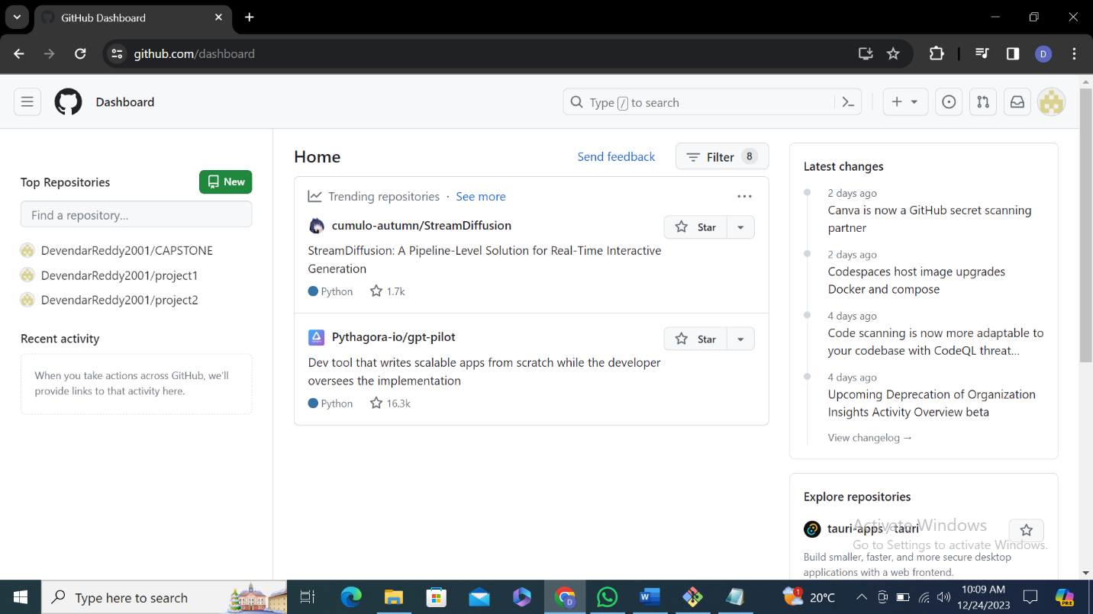

**LOCAL REPO to GITHUB**

git remote add origin https://github.com/DevendarReddy2001/gitdb22.git

git push origin master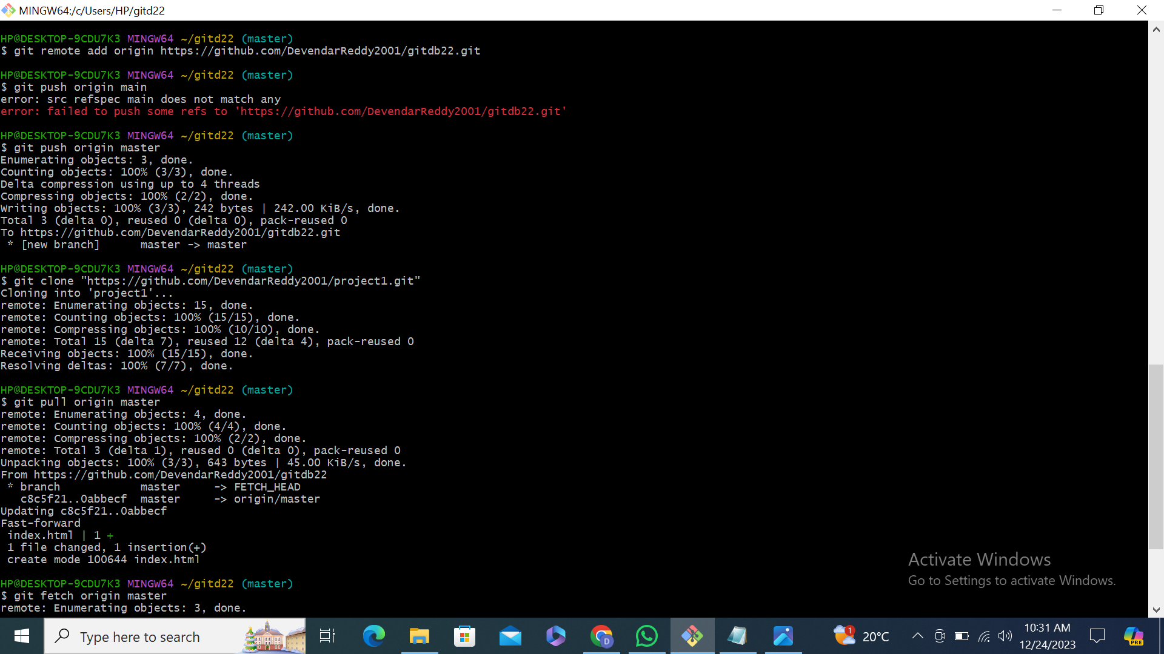

git clone <https://github.com/DevendarReddy2001/project1.git>

git pull origin master

git fetch origin master

